**Task Designing a Real Time System**

**Introduction**

It’s required to design a healthcare system using RTOS with the following requirements: -

1. A touch LCD as input that can control the system and give commands. Every LCD command is represented in 4 bytes. LCD is connected to the micro-controller through UART with speed 9600 bps [Bit per second]. (Reading 4 bytes and processing the command takes 2 ms)
2. Blood pressure sensor with new data every 25ms. (Reading the sensor and processing its data takes 3 ms)
3. Heart beat detector with new data every 100ms. (Reading the sensor and processing its data takes 1.5 ms)
4. Temperature sensor with new data every 10ms. (Reading the sensor and processing its data takes 2.5 ms)
5. Alert siren. (Activate or deactivate the siren takes 1 ms).

**Task Deliverables**

1. Decide how many tasks are needed.
2. Decide the task parameters (Priority – Periodicity – Deadline).
3. Decide the system tick rate.
4. Calculate:
   1. Hyperperiod
   2. CPU load.
5. Draw the timeline manually and analyze system schedulability.
6. Model the system in Simso and verify that your design is schedulable.
7. Provide a report with the above points using screenshots and comments on

**System Overview**

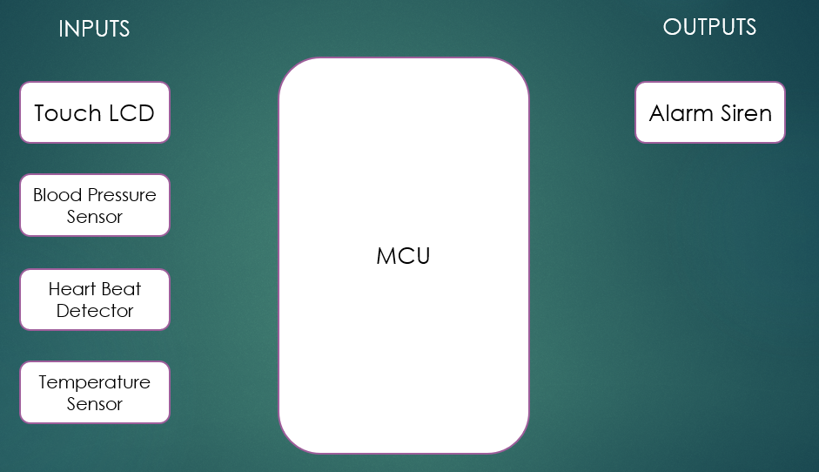

**System Tasks**

1. Task taking input from touch LCD through UART and processing the input command.  
   {Periodicity: 50 ms, Deadline: 50 ms, Worst Case Execution Time: 2 ms, Priority: 2}.
2. Task reading blood pressure sensor and processing its data.  
   {Periodicity: 25 ms, Deadline: 25 ms, Worst Case Execution Time: 3 ms, Priority: 3}
3. Task reading heart beat detector and processing its data.  
   {Periodicity: 100 ms, Deadline: 100 ms, Worst Case Execution Time: 1.5 ms, Priority: 1}
4. Task reading temperature sensor and processing its data.  
   {Periodicity: 10 ms, Deadline: 10, Worst Case Execution Time: 2.5 ms, Priority: 4}
5. Task responsible for activating/deactivating the alarm.  
   {Periodicity: 100 ms, Deadline: 100 ms, Worst Case Execution Time: 1 ms, Priority: 1}

**System Tasks - Design Notes**

1. A task deadline was chosen equal to the task periodicity, which is the maximum allowed deadline for a task.
2. Task for reading LCD input was given a suitable periodicity for detecting user clicks equals to 50 ms.
3. Priorities of the tasks were given according to the analysis found in the next sections.

**Scheduling details**

1. Scheduling policy used is “Fixed Priority”.
2. Hyperperiod is selected as Least Common Multiple of the periodicities [10, 25, 50,100] (ms) which is equal to 100 ms.
3. Systick rate is selected as Greatest Common Factor of the periodicities [10,25,50,100] (ms) which is equal to 5 ms.

**Manual Tasks Timeline Drawing**

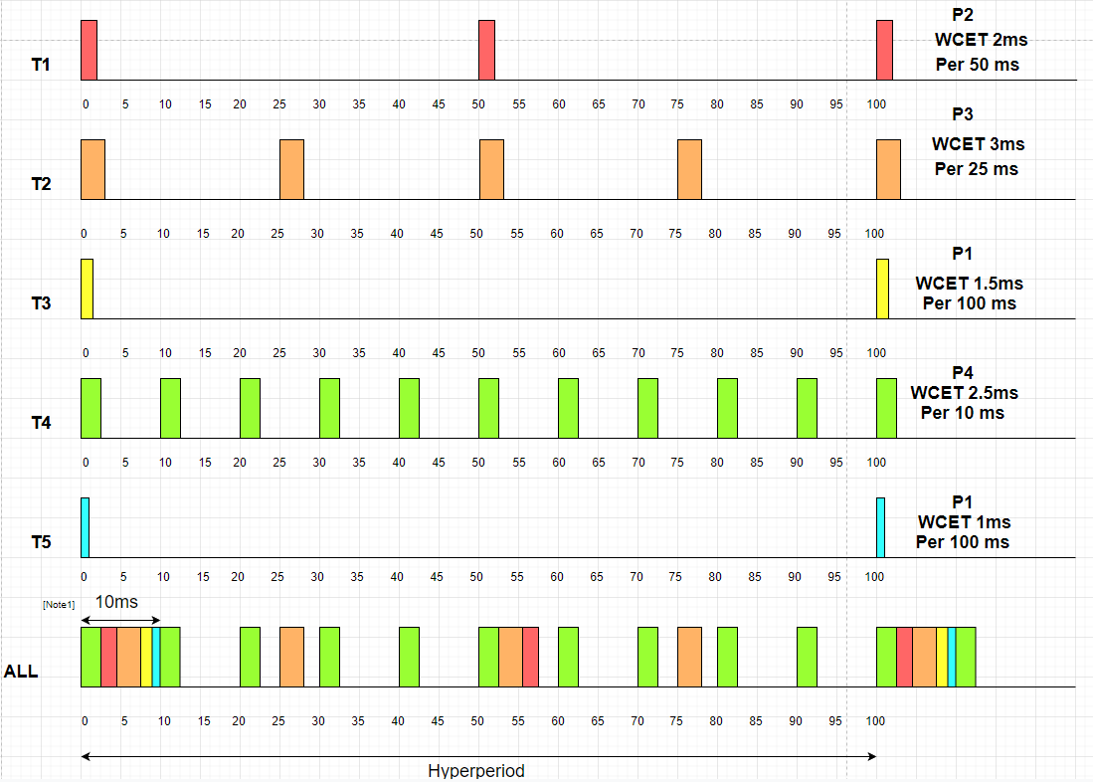

**Manual Tasks Timeline Drawing – Notes**

1. Each task is drawn as if it’s the only task running in CPU.
2. In the All timeline, tasks are drawn in case all of these tasks with different priorities and periodicities are run on the same CPU with Fixed Priority scheduling policy.
3. Total WCET of all tasks is 10 ms as per Note1, hence Task 4 (Periodicity 10 ms) should be given highest priority for the system to be able to have more tasks added (new tasks having higher periodicity).

**Manual Tasks Timeline CPU Load Calculation**

$CPU Load$ = $\frac{∑ Tasks Execution Time during Hyperperiod}{Hyperperiod}$

$CPU Load= \frac{∑(\frac{Hyperperiod * WCeT }{Periodicity} )}{Hyperperiod}= \frac{\frac{100*2}{50}+\frac{100*3}{25}+\frac{100*1.5}{100}+\frac{100*2.5}{10}+\frac{100*1}{100}}{100}=0.435=43.5 \%$

**Manual Tasks Timeline Drawing – Observations**

1. System is schedulable as none of the CPU task is exceeding its deadline.
2. System is healthy and can take more tasks as long as the highest periodicity task has the highest priority.

**SIMSO System Simulation – Gantt Chart**

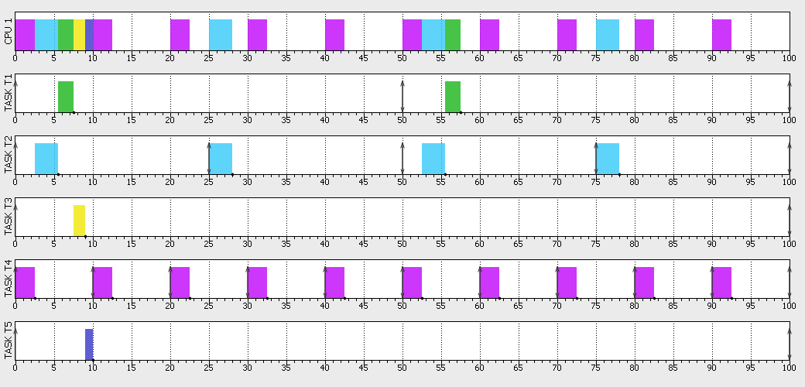

**SIMSO System Simulation – Gantt Chart – Notes**

1. Each task is drawn here taken intro consideration execution of other tasks in the same CPU.

**SIMSO System Simulation – Gantt Chart – Observations**

1. None of the tasks is exceeding its deadline.
2. System is schedulable.

**SIMSO System Simulation – Results**

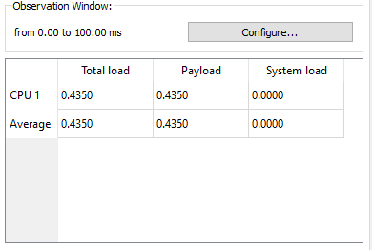

**SIMSO System Simulation – Results – Observations**

1. CPU load calculated by tool is equal to the CPU load calculated manually.